**MEMORANDUM**

From: Daniel DeLuca

To: Pr. Craig

Date: 12/06/21

Subject: Analysis of Climate Change Data

**Section 1: Introduction and Overview**

The issue I will be analyzing data on is climate change. Specifically, how the average United States temperature has changed throughout the years, and if it is affected by carbon dioxide emissions. I hope to find how cumulative carbon dioxide emissions effect United States average temperatures. Climate change is heavily talked about in the modern day. This is because changes in the climate, such as increases in temperature have massive effects on many aspects of the world for our generation and future generations. I am interested in this topic because it is important to see what the world will look like in the future and how climate change will affect the future world.

**Section 2: Statement of Hypothesis**

My null hypothesis (H0) is “carbon dioxide emissions cause an increase to United States temperatures”. My alternative hypothesis (H1) is “carbon dioxide emissions do not cause an increase in United States temperatures”. I will establish with confidence that carbon dioxide emissions and United States temperatures have a correlation.

**Section 3: Data Analysis Methodology**

The first data set I obtained is from the National Centers for Environmental Information. This data set contained the average annual temperature for the United States since the year 1895. This is important because this data will show how temperatures have increased since 1895. From 1895 to 1900 the average temperature was 51.52 degrees Fahrenheit and the average temperature from 2016 to 2020 is 54 degrees Fahrenheit. This sample from the data set shows an increase in annual United States temperatures. Now that I knew the data supports that United States temperatures have increased, I found my second data set. This data set was obtained from GitHub and showed information about carbon dioxide emissions. This data set showed statistics of carbon dioxide emissions for each country since 1803. I filtered the data to show only United States data then further filtered it to match up with the start of the average temperature data set. I then took the relevant information from each data set, such as U.S. average temperature, U.S. cumulative carbon dioxide emissions, U.S. carbon dioxide growth percentage, and global cumulative carbon dioxide emissions, and copied it into Minitab to perform my analysis. The tests I will perform in Minitab will be correlation tests and regression tests. The correlation tests will show if there is a strong, a weak, or no correlation between average United States temperature and U.S. cumulative carbon dioxide emissions since 1895, and the correlation tests will show if there is a strong, a weak, or no correlation between average United States temperature and global cumulative carbon dioxide emissions since 1895. The regression analysis will show what percentage of United States annual temperature is influenced by U.S. cumulative carbon dioxide emissions, and will show what percentage of United States annual temperature is influenced by global cumulative carbon dioxide emissions,

**Section 4: Results**

**Correlation**

In this analysis, I have performed a correlation test to see if U.S. carbon dioxide emissions and annual temperature in the United States are correlated.

**Figure 1**

**Figure 1:** The information displayed in figure one shows that there is a decently strong correlation between U.S cumulative carbon dioxide emissions and U.S. average temperature. This correlation is show by the points on the graph and the “r” value of .607. The “r” value is the coefficient of correlation, and it shows how strong the relationship is between the two variables. The “r” value of .607 shows that there is a decently strong positive correlation between the variables, and as U.S. cumulative carbon dioxide emissions increase so does average U.S. temperature. However, the “r” value does not solely determine causation and further testing and analysis was needed.

**Regression Analysis**

In this analysis, I have performed a regression analysis to see if U.S. carbon dioxide emissions influence annual temperature in the United States.

**Figure 2**

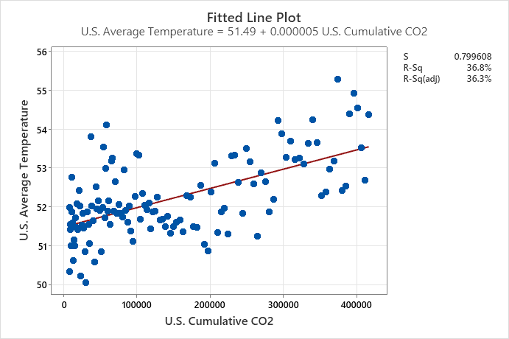

**Figure 2:** The information displayed in figure two shows the regression analysis of U.S. cumulative carbon dioxide emissions and average temperature in the United States. This scatterplot shows, through the line of best fit, that there is a positive relationship between of U.S. cumulative carbon dioxide emissions and average temperature in the United States. The R-squared value shows that U.S. cumulative carbon dioxide emissions influence average temperature in the United States. The R-squared value is the measure of explanatory power. This means how much of the independent variable is influenced by dependent variable. The R-squared value in this scatterplot is 36.81%. The R-squared value of 36.81% shows that U.S. cumulative carbon dioxide emissions have a 36.81% influence on the United States average temperature. This also means that 63.19% of U.S. average temperature is influenced by other factors. With this information obtained from the scatterplot I can determine that U.S. cumulative carbon dioxide emissions causes an increase on average United States temperature. This reinforces my null hypothesis

**Figure 3**

**Correlation**

In this analysis, I have performed a correlation test to see if global carbon dioxide emissions and annual temperature in the United States are correlated.

**Figure 3:** The information in this graph shows how global cumulative carbon dioxide emissions and U.S. average temperature are related. The “r” value of .623 shows there is a decently strong positive relationship between global cumulative carbon dioxide emissions and U.S. average temperature. The information in this graph reinforces my null hypothesis that carbon dioxide emissions cause an increase in U.S. temperatures.

**Regression Analysis**

In this analysis, I have performed a regression analysis to see if global carbon dioxide emissions have an influence on annual temperature in the United States.

**Figure 4**

**Figure 4:** The information displayed in figure 4 shows the regression analysis and fitted line plot of global cumulative carbon dioxide emissions and U.S. average temperature. This scatterplot shows that there is a positive relationship between the two variables. This means as global cumulative carbon dioxide emissions increases so does U.S. average temperature. The R-squared value of 38.8% shows that 38.8% of U.S. average temperature can be explained by global cumulative carbon dioxide emissions. The R-squared value of 38.8% further reinforces my null hypothesis that carbon dioxide emissions cause an increase to United States temperatures.

**Section 5: Conclusion and Discussion**

For this data analysis project, I tested the influence of carbon dioxide emissions on U.S. average temperatures. I created the null hypothesis that stated, “carbon dioxide emissions cause an increase to United States temperatures”. Then to test this null hypothesis I acquired data from multiple sources and organized it into a Minitab file. In Minitab I then ran multiple correlation and regression tests using the organized data. The correlation tests and regression tests gave me results that supported my null hypothesis. The correlation tests reinforced my null hypothesis by showing there was a decently strong correlation between the two variables. The regressions tests reinforced my null hypothesis by showing the carbon dioxide data has an influence on the average temperature data.

**References:**

NCEI.Monitoring.info@noaa.gov. “Climate at a Glance.” *National Climatic Data Center*, https://www.ncdc.noaa.gov/cag/national/time-series/110/tavg/ann/10/1895-2021?base_prd=true&begbaseyear=1901&endbaseyear=2000.

Owid. “OWID/CO2-Data: Data on CO2 and Greenhouse Gas Emissions by Our World in Data.” *GitHub*, <https://github.com/owid/co2-data>.